**Best Quality PCB From JLCPCB _ Unboxing Of JLCPCB PCB**

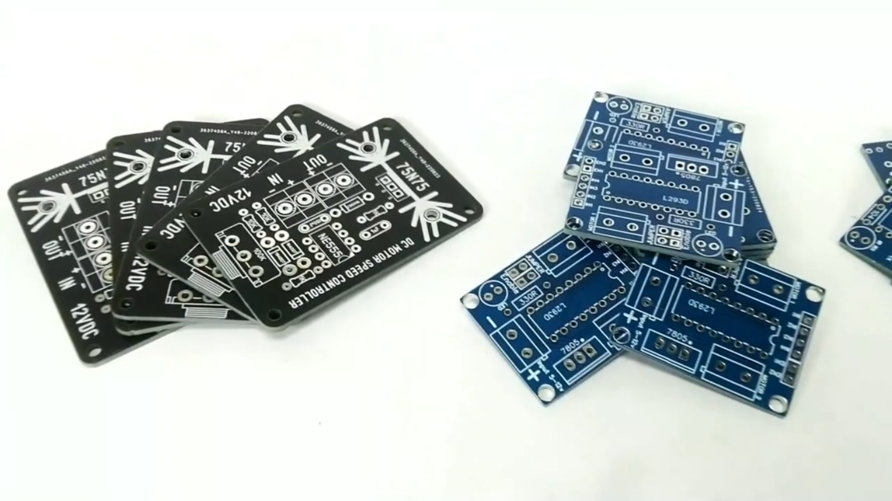

Hello everyone, welcome to another interesting blog of YK Electricals. In this blog we will see how you can manufacture your own PCB with professional touch from the world's fastest PCB manufacturer. You guys have already seen those high quality PCBs in our previous videos, from there you can get an idea of how good those PCBs are in both quality and appearance. You also have the freedom to choose the color of your choice.

**Why JLCPCB**

Founded in 2006, JLCPCB has been at the forefront of the PCB industry. With over 15-year continuous innovation and improvement based on customers' needs, they have been growing fast, and becoming a leading global PCB manufacturer, who provides the rapid production of high-reliability and cost-effective PCBs and creates the best customer experience in the industry.

**Higher Quality**

Ensuring quality and its consistent improvement are the two main guidelines of their company.

Their advanced PCB technology allows them to provide high precision boards suitable for industrial, military, aerospace, and medical applications.

They are continuously investing top-level base materials and advanced equipment for fully automated production lines, which enables them to offer their customers high throughput with consistently high quality.

**Lower Cost**

Since 2006, JLCPCB has continuously driven to become more efficient and reduce costs. They promise to offer customers the most economic PCBs forever. JLCPCB makes cheapest but top quality PCBs possibly because of scale effect, extremely high production efficiency and less manpower cost.

**Faster Delivery**

Their easy-to-use online ordering system, professional and efficient customer service, digital manufacturing technology, full-automatic production lines, and stable logistics partners make every step to deliver you PCBs faster.

**Ordering PCB from JLCPCB**

Ordering a PCB from [JLCPCB](https://jlcpcb.com/?from=IAD) is quite simple and easy.

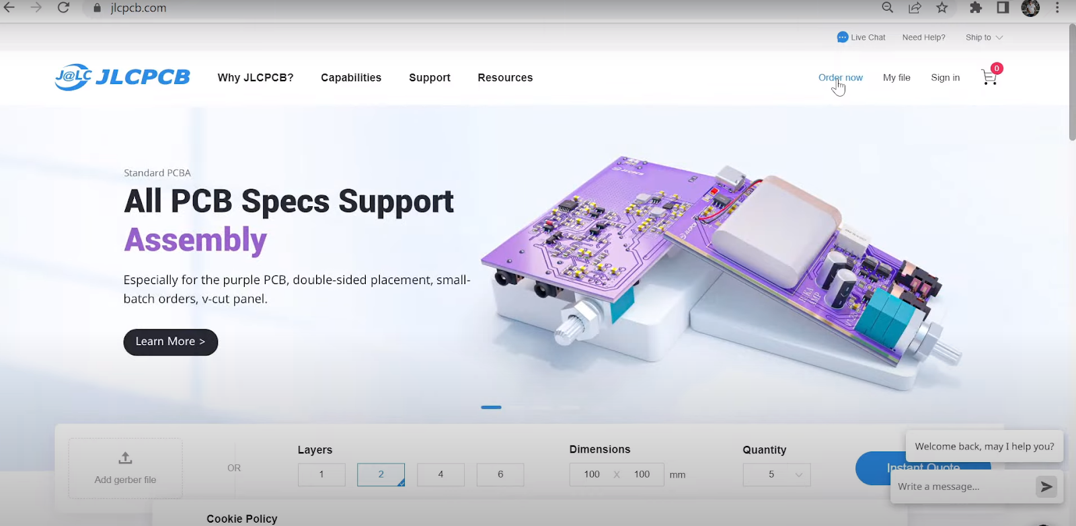

You just have to upload your gerber file (max up-to 6 layers) , select layer, color and dimensions and add to your cart then checkout securely and the sum. That's it no your designed PCB is at your doorstep within 10 to 14 days (fast and safe shipping). Remember you can start designing your PCB only from 2 $.

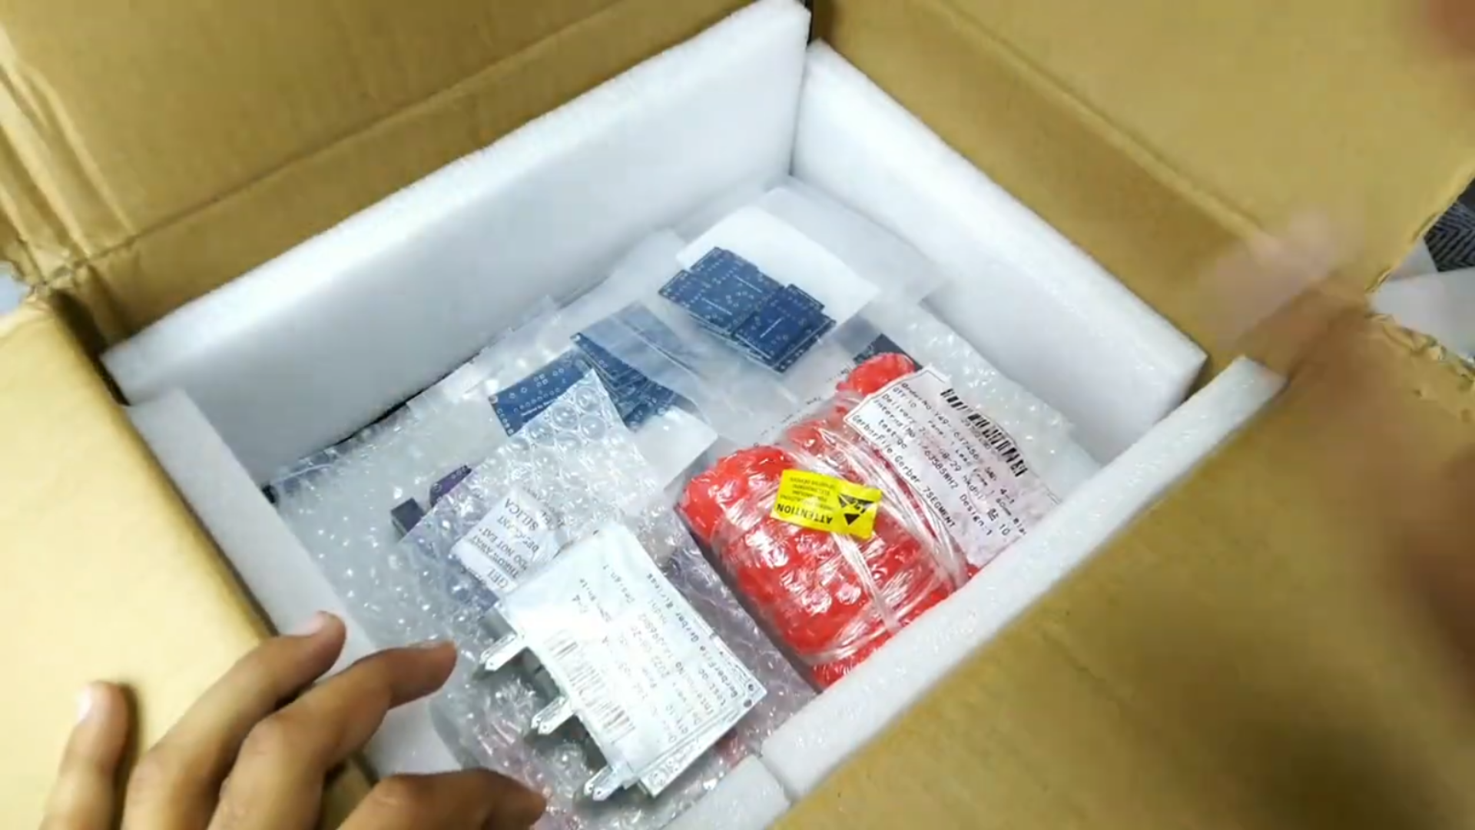

**Unboxing of PCBs**

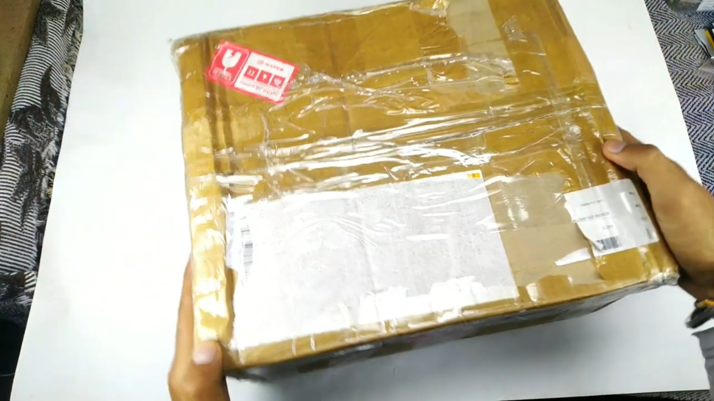

We have ordered some PCBs from JLCPCB (delivered within 10 to 14 days) for our future projects, which videos and blogs will be available soon, so stay tuned and let's see what we got in that box..

Talking about their packaging and safety of the product which is so good in fact we can say that they have tried their best to protect our product from any kind of damage.

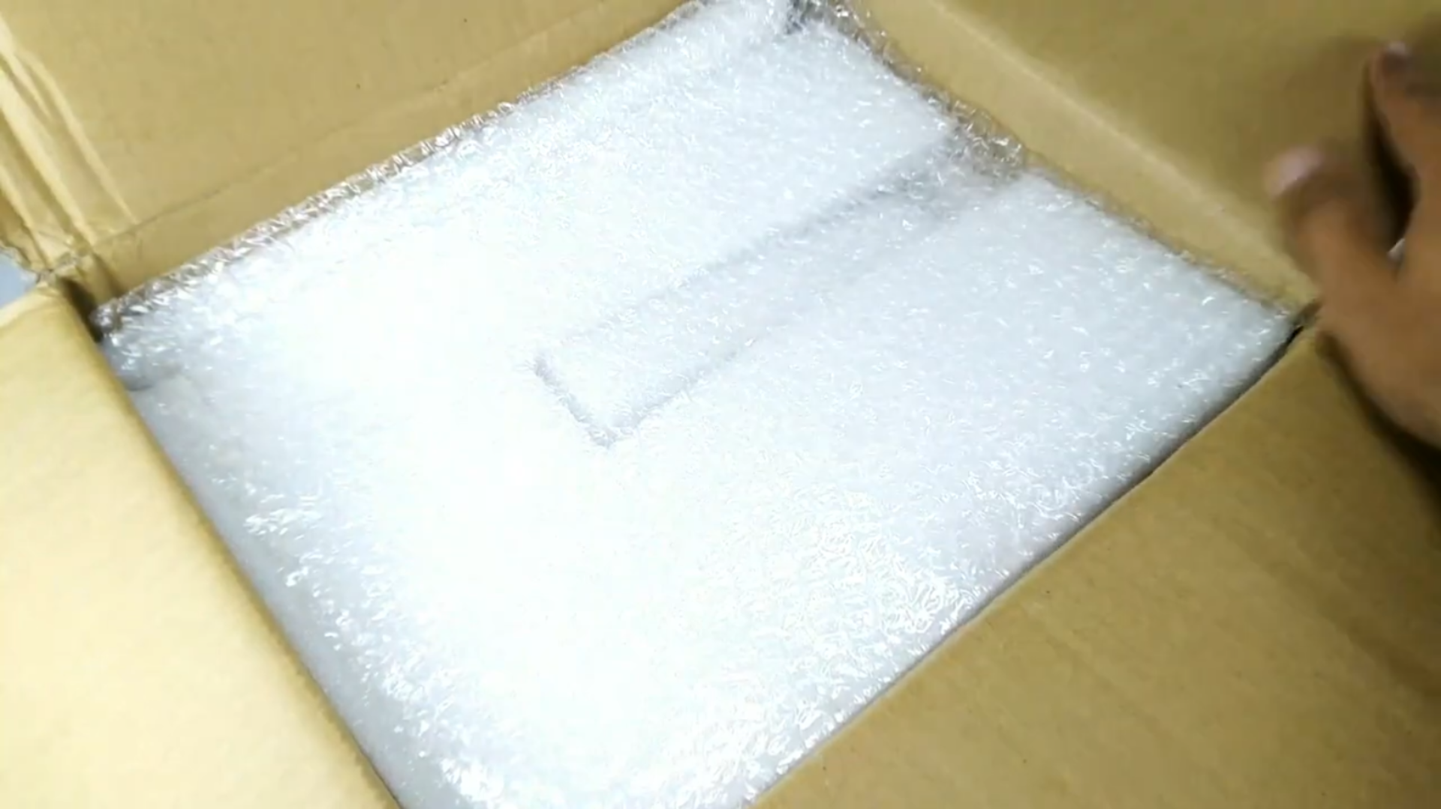



After unwrapping those safety bags we will see our PCBs. We have ordered many PCBs as you can see from the above picture for future projects. There are PCBs we ordered in Panelized form. Panelized PCB means there are multiple PCBs designed on a single Board. Also we have ordered the PCB in singular form.

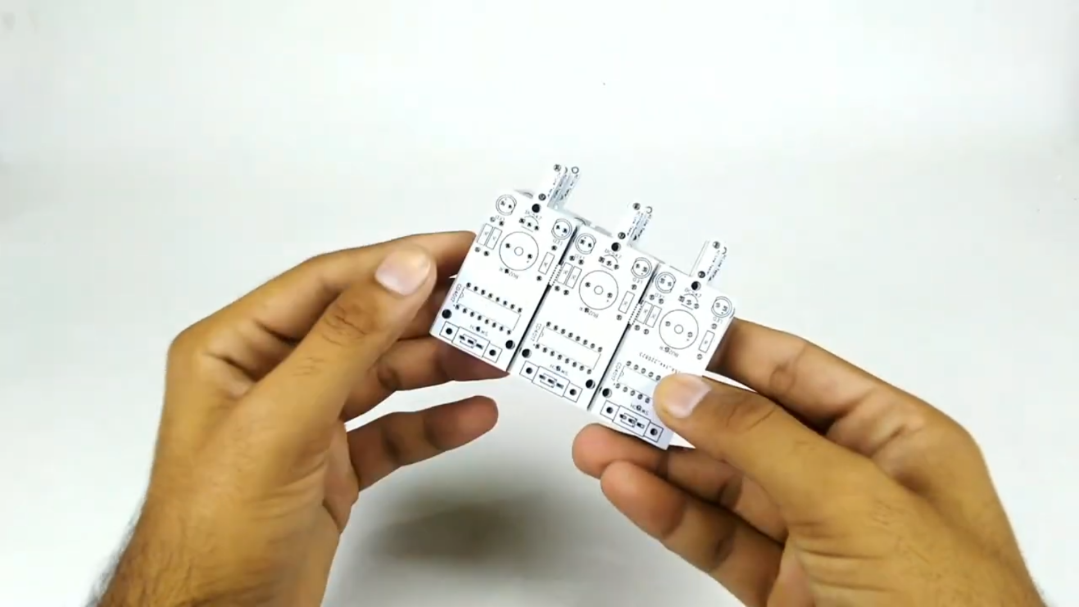

Here is the picture of a Panelized PCB for a Voltage tester. The benefit of Panelized PCB is that you get more PCBs on a single Board. And getting a single PCB from a Panelized one is so easy you just have to carefully apply pressure in between those single PCBs.

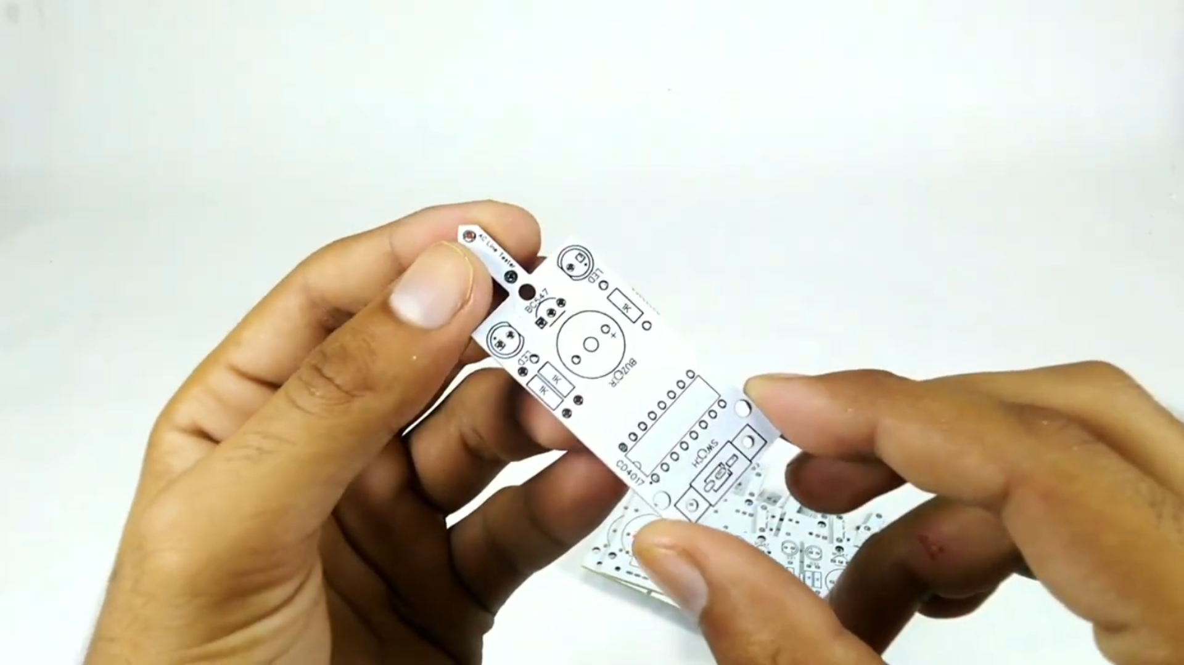

And some PCBs we have we ordered in district form which is one PCB on one board, below is a picture is single PCB.

